**BUGATTI DIVO**

[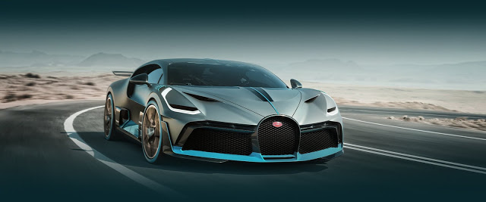](https://4.bp.blogspot.com/-STdnkrwc7mk/W8r4d8k57GI/AAAAAAAAAXs/d4NXHc5_Wb4In2eCufAIgpvVf2k3JYaVgCLcBGAs/s1600/se-image-472895835edf91a5b24d3974a05db7c5.jpg)

Who doesn't love car's. If a car is a [supercar](https://en.wikipedia.org/wiki/Supercar) then what do you say? Want to buy a super car? Oh come on, everybody does. Same for me.

In our day to day life, role of car is unthinkable. Public transportation is not that much reliable for everyone. That's why soo much people wants to have their own car. On this point you will agree with me. But if you have a plenty of money, and don't know where to spend them, then this article is for you.

 There is a new marvellous car from [Bugatti](https://www.bugatti.com/home/). It's name is  [BUGATTI DIVO](https://www.bugatti.com/divo/). Last week, Bugatti revealed its latest supercar slayer, The Divo. Keeping with the tradition of naming its cars, the Divo acquires its name after the French racing car driver [Albert Divo](https://en.wikipedia.org/wiki/Albert_Divo) who won the [Targa Florio](https://en.wikipedia.org/wiki/Targa_Florio) mountain sprint **twice in the Twenties**. Bugatti President [Stephan Winkelmann](https://en.wikipedia.org/wiki/Stephan_Winkelmann) said  at the new model’s unveiling in California:

The Divo is made for bends

[](https://3.bp.blogspot.com/-qgSqUEGws2s/W8r5r-XwygI/AAAAAAAAAX4/CR-jTbCbuXICcTdq-B_g0d_tJ36EtdMjgCLcBGAs/s1600/Stephan-Winkelmann-Bugatti-Gear-Patrol-Lead-Full.jpg)

 What marks the **Bugatti Divo** so singular is that there are only **40 pieces** available worldwide. For avoid car indulgence car collectors, this will make you squeal. Unluckily, all 40 have already been **sold** at **five million euros** to present [Bugatti Chiron](https://www.bugatti.com/chiron/) owners before it made its public presentation. So, why the hurdle in price? It's because of deviations in the car's smoothness programme, suspension advancements and changes to the chassis. The Divo is about **35 kg** lighter than the Chiron and acquires about **90 kg** more downforce with enhanced horizontal speeding up.

[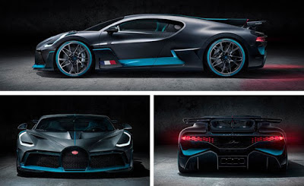](https://1.bp.blogspot.com/-TlU7bk1sSWU/W8r5_2SFgqI/AAAAAAAAAYA/vbHcAWx9xTMqBR-LUte8pyN4U4_kHO6LgCLcBGAs/s1600/bugatti-divo-inline1-1535123805.jpg)

Comprehensive changes have been made to the outer to improve on the Chiron's vigorous ability. The front unit has been completely reformed into a narrower shape. A large front splitter boosts downforce and feeds mid-air to the enlarged consumptions, while new perpendicularly oriented LED headlights provide the Divo a unique lighting signature.

[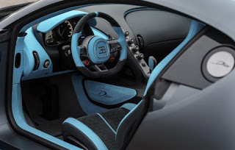](https://3.bp.blogspot.com/-mu9qTNY_y8Q/W8r6JmnYprI/AAAAAAAAAYE/g7D4_wDepUAAds4hNBodGHj_5VhwEIdOgCLcBGAs/s1600/bugatti-divo_100668078_m.jpg)

The engine is the similar **8-litre 16-cylinder** engine generating **1,500 hp** that approaches from the Chiron and [Veyron](https://en.wikipedia.org/wiki/Bugatti_Veyron) but the speed is automatically limited to **236 mph**. That’s about **30 mph** gentler than the Chiron top speed has been limited to **380 kph** on behalf of it wants the Divo to be more of a roadway focussed car than outright straight line speed. The Divo has lap up the [Nardo circuit](https://en.wikipedia.org/wiki/Nard%C3%B2_Ring) 8 seconds quicker than the Chiron

[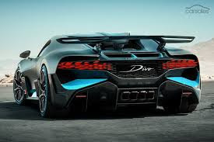](https://3.bp.blogspot.com/-989JPjuWpKw/W8r6ZF-a6-I/AAAAAAAAAYQ/nxyRAt0ksrUcGiZ_Mrg2RHUnxgh6AH0ygCLcBGAs/s1600/images%2B%25281%2529.jpg)

At the outward edge, the fins look broader and brighter; toward the midpoint of the car, they look narrower. The outcome looks like a gradual light fade crossways the back of the car. Manufacture of the Bugatti Divo jumps soon in [Molsheim](https://en.wikipedia.org/wiki/Molsheim), France.